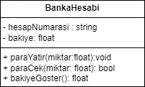**1.SORU**

MOHAMMED MASHHOR ALMASHHOR

9211118091 2. Sube

**2.SORU**



**3. SORU**



**4.SORU**

